User Documentation

This program uses java and a java IDE (integrated development environment) is required to run the program. To get the best results the java IDE jGrasp is recommended. You can find and install it for free at the java website.

This program is used to manage a restaurant management system. It can be used to search current inventory for specific ingredients or dishes, cook a dish and many more. The program will prompt you for an option and you will be able to choose whatever you want to do. Any incorrect inputs will be accounted for and you will be able to re-enter the desired data.

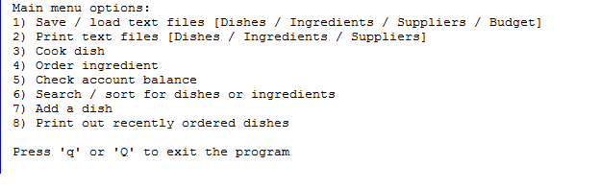

This is the main menu for selecting what you want to do. As shown above, you make your selection using the integer value beside each option and you can exit the program at anytime by entering q or Q.

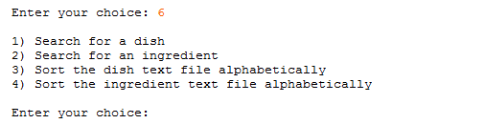

Every option will have easy to follow sub-options that allow you to further specify with what you want to do with the program. For example, in the main menu when you enter option 6, a sub-category of options will be available for you to choose from.

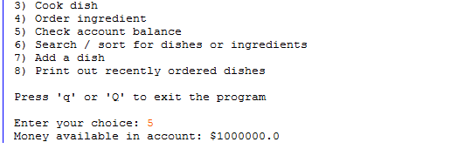

This is an example of what the program will display after you finish selecting an option. The program will continuously ask you to enter a selection until an exit command is given.

Text files are used to manage what each class contains. The classes that use text files are dishes, drawers, supplier and budget. The text files contain the information about the current inventory status, a list of suppliers for ordering ingredients and the budget amount. It will be loaded automatically in the beginning of the program.

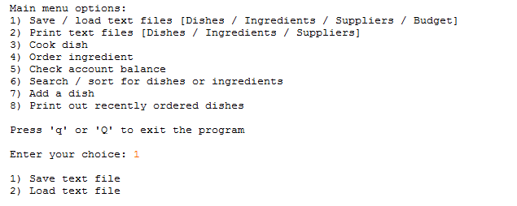

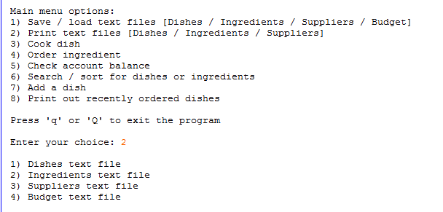

The above are the available options that work with the text files. Text files can be saved, loaded and are differentiated between the four classes that utilize it. The options are displayed in a clear manner to be more user-friendly.

The text file names are stored as constants in the main method and there are methods that will call these constants to read these text files. The text files are located in the folder that contains all the program files and should not be moved or renamed in any way.

Inside the program folder there is a subfolder called “Text Files”, this subfolder contains all the text files required for the program to run and this is where you will be putting all your information text files in. The program reads and uses the text files from this subfolder. This folder should only contain text files and no other components of the program.